**NAME: ROHAN BHARAT CHAVAN  
ROLL NO: 243544**

**Assignment 2**

Q1. In your Github account, create a new repository ‘linux_assignments’. Put all the docx/pdf file solutions for your linux assignments in that folder

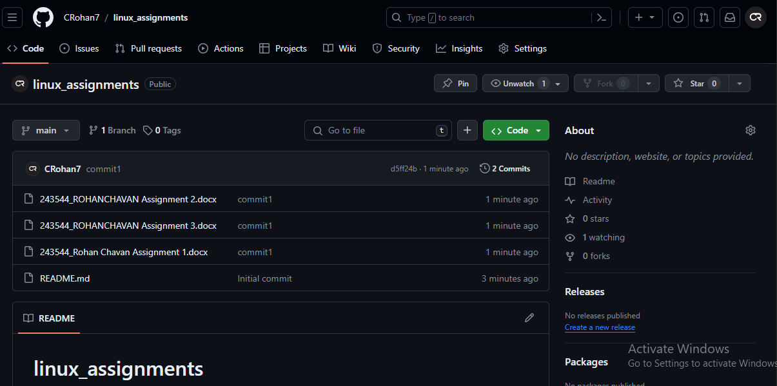

Q2. In your Github account, create a new repository ‘linux_scripts’. Put at least 5 .sh files in that folder.

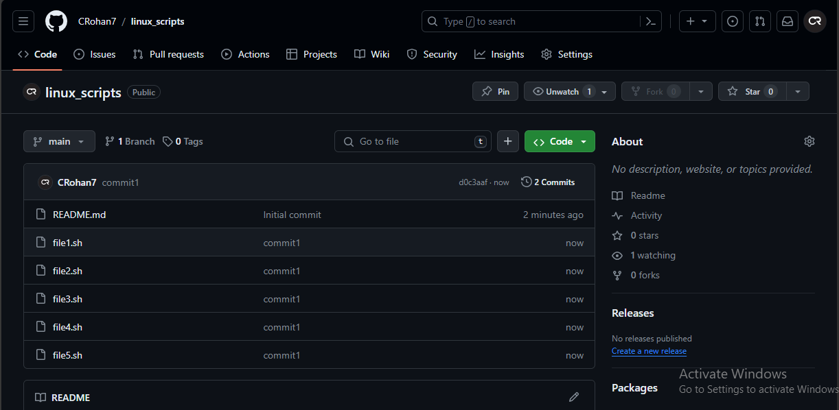

Q3. Login to AWS console. Create a new instance of EC2 with Ubuntu. On this instance install git

1. Created EC2 instance with Ubuntu

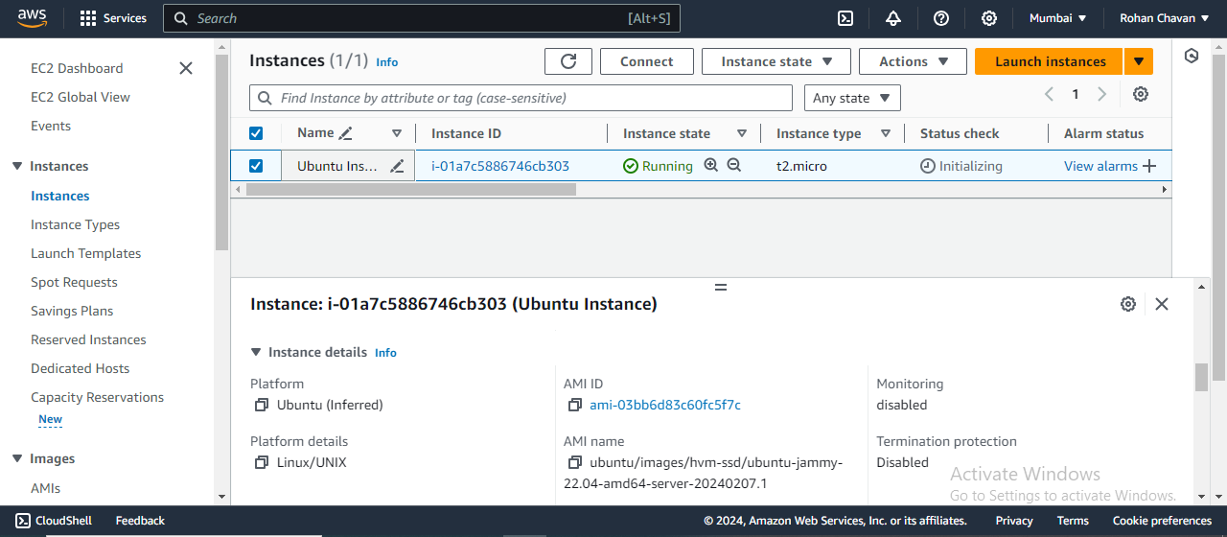

1. Installing Git on Ubuntu

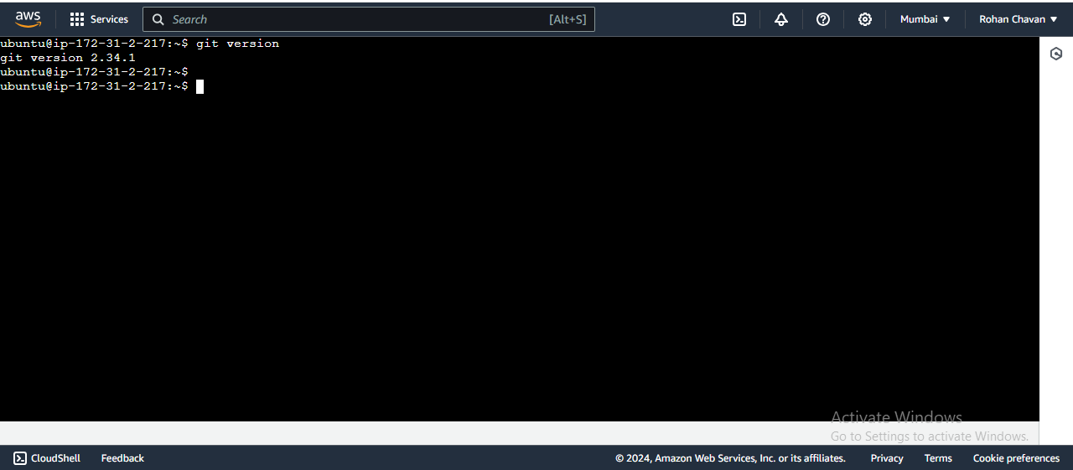

Q4. After installing git, pull your repository named ‘linux_scripts’. Run scripts inside this repository on ec2 instance. Take screenshots and save them in a docx file.

1. Cloned repository

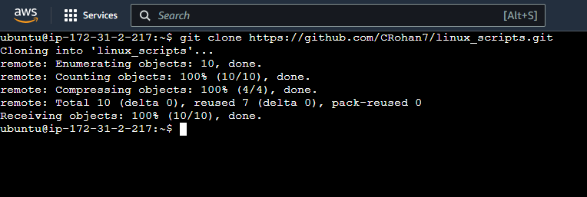

1. Gave execution permission of all files to owner ubuntu

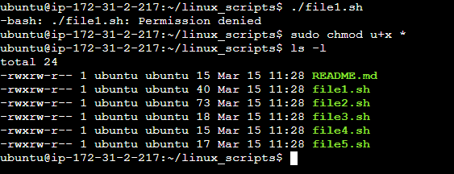

1. Executed all the shell files

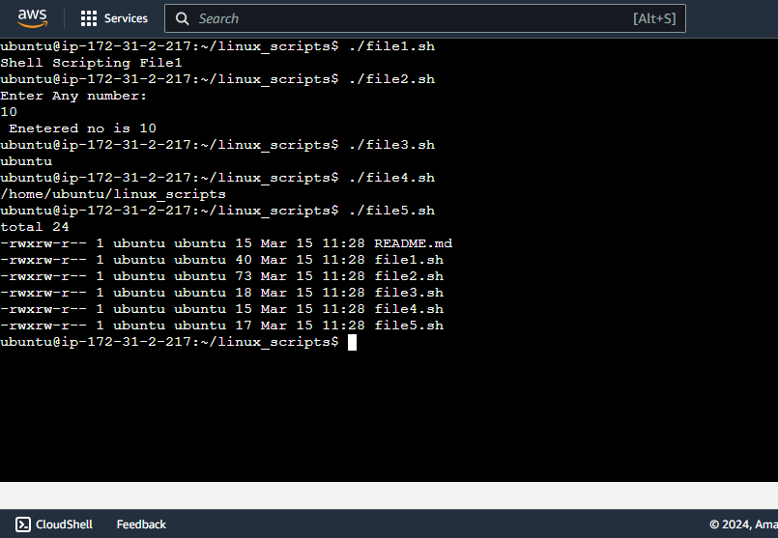

Q5. Create a new repository on Github named “linux shell scripting with AWS”. Put the docx file created in Q5 in this repository.

